Why not generating multiple plan in Planner agent like mapcoder:
MapCoder's ranking has a real weakness worth naming directly: it asks the same LLM that wrote the plan to self-assess how confident it is, before any code has run. That's exactly the kind of unverified self-judgment Huang et al. (2024) found unreliable and we've seen it directly in our own data: qwen stated a "FINAL ANSWER" with full apparent confidence while the value was fabricated. Self-reported confidence isn't grounded in anything real.
It's more token-efficient MapCoder's own limitations section admits they never solved the cost of generating k plans upfront when most go unused; this avoids that entirely.
It's better grounded in the Huang et al. (2024) finding what makes iteration help is external, verified feedback, not just having more options to choose from. A fresh plan, based on the feedback of the produced result, written in direct response to a concrete, real failure is exactly that; picking from a pre-generated shelf of untested plans isn't.

How our Coding + Validation genuinely differs from MapCoder's Coding + Debugging a real, fundamental distinction, not just a naming choice

The critical difference: MapCoder's test() function checks code against known, ground-truth sample input/output pairs competitive programming problems come with worked examples (sum_squares([1,2,3]) == 14) that the code can be checked against before the model commits to a final answer.
Our task structurally cannot do this. The real Moran's I value is the thing we're testing whether the model can compute handing it over as a "sample answer" to check against would make the whole experiment circular. There is no equivalent of a sample I/O for "is this borough's spatial clustering significant."
This means our Validator can only ever check mechanical plausibility, never substantive correctness. It can catch nan, an impossible p-value, or a hardcoded literal but it cannot catch a well-formed, finite, correctly printed number that's simply the wrong method. Recall gpt-4o-mini's sign-matching proxy on the change-spillover NO2 case real, finite, correctly printed, and it would pass every one of our checks, despite being analytically weaker than real Moran's I. This is a genuine, honest limitation worth stating plainly in the thesis, not glossing over and it's precisely why MapCoder's approach doesn't transfer directly: they have access to objective ground truth pre-answer; open-ended statistical inference on real data does not.

Justifications: Issues needed to be addressed through multi agent framework (Generic)
Validation tasks
Check General principle it's really an instance of Generic because
Finite statistic (none, infinity checking) | Output validity a basic postcondition of any numerical computation | This is a universal sanity check for any pipeline outputting numbers, statistical or not
p ∈ [0,1] | Definitional correctness this is what a p-value is, by mathematical definition | True for any valid significance test, regardless of method
Variable-reference, not hardcoded ("statistical method = Global Moran's I) – Instead of giving a number giving hardcoded values, or in place of value giving string like Global Moran's I | Provenance / no fabrication | A standard reproducible-research requirement, a reported number must trace to real computation
Permutation count ≥ 500 | Enforcing own stated methodology | This was already in the original prompt for every model on every task the check just verifies compliance, it isn't new
n_used reconciliation  expected_n_used = 33 -profile_output["missing_count_for_this_column"]  actual_n_used = parsed from Coder's printed  "n_used = X" IF actual_n_used != expected_n_used: | Data completeness accounting standard practice in any analysis involving exclusions | A domain-general requirement wherever data can be legitimately excluded
Re-execution determinism-  the sandbox re-runs the exact same code a second time (free, no new LLM call); the observed test statistic must match across both runs (the permutation-based p-value is allowed to vary, the statistic itself should not) | Reproducibility a cornerstone of scientific computing: same input, same code same output | Universal property expected of any deterministic statistical computation, unrelated to spatial statistics specifically

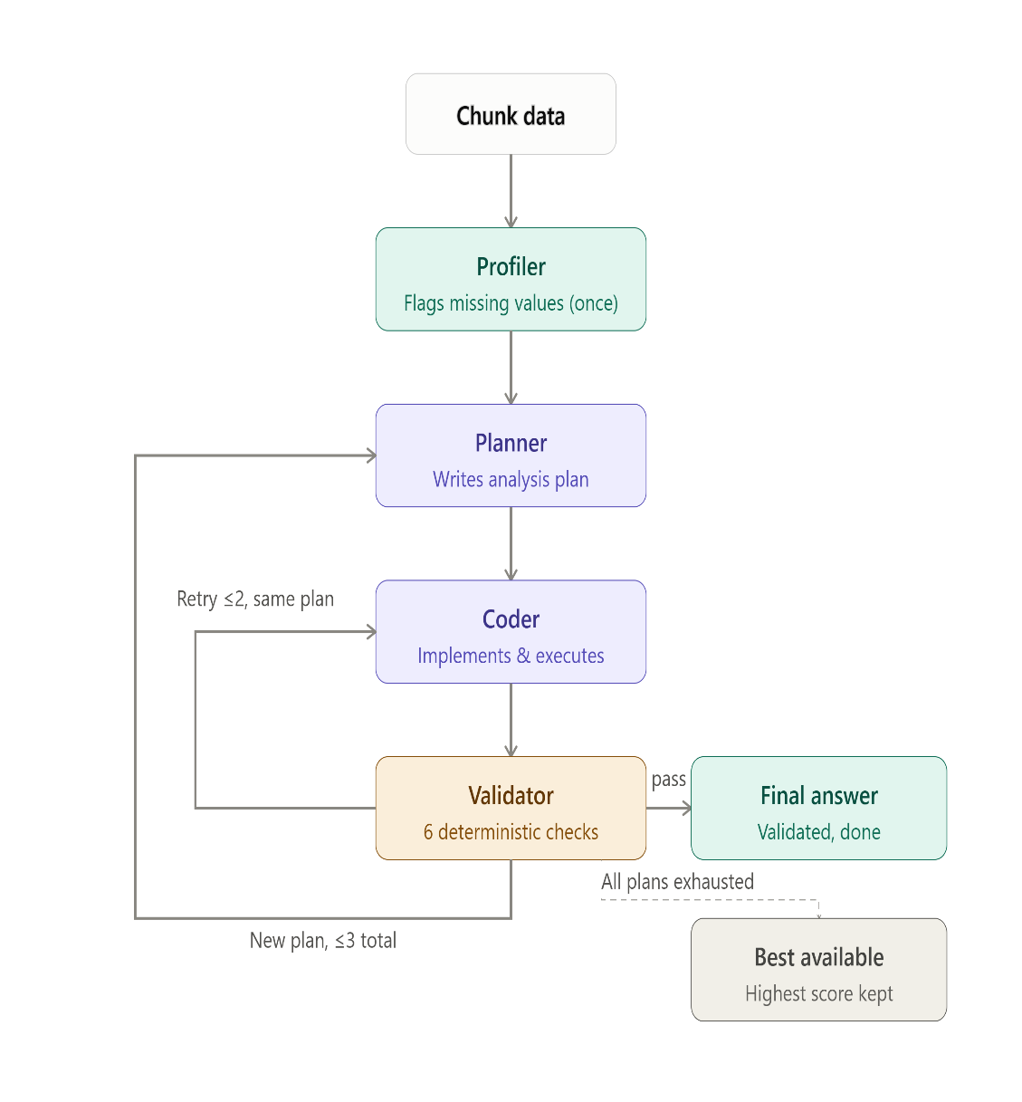

User prompt
I've attached NO2 values for 33 London boroughs for the years 2021, 2022, and 2023, and a list showing which boroughs are geographic neighbors of each other.

Question: Do boroughs that saw a large CHANGE in NO2 between 2021 and 2022 tend to be located near other boroughs that ALSO saw a similarly-sized change in the SAME direction (both increasing, or both decreasing), or does a borough's change show no relationship to its neighbors' changes? This tests whether the CHANGE itself clusters spatially, not just the raw level in any single year.

(Note: the data includes a third year not needed for this question.)

Explain your reasoning based on the data, including the actual computed statistic and its significance. You can use a statistical method such as Global Moran's I, or another appropriate method of your choosing, to support your conclusion.

Note: dedicated spatial-statistics packages (pysal, esda, libpysal, geopandas, or similar) are NOT installed in this environment -- don't spend turns trying different import paths for them. Implement your chosen method directly using only pandas and numpy. If you test statistical significance via a permutation/randomization test, use at least 500 random shuffles -- fewer permutations can produce an unstable p-value that lands on the wrong side of the 0.05 threshold just by chance, especially when the true effect is only moderate.

End your response with exactly one line, including the computed number(s) you used:
FINAL ANSWER: CLUSTERED (test statistic = <value>, p = <value>)
or
FINAL ANSWER: NOT CLUSTERED (test statistic = <value>, p = <value>)
(test statistic is just an example label -- if your method produces a different statistic, use its name instead, but the value after '=' must be a real number)

System prompt

Single Agent
SYSTEM_PROMPT = """You are a single AI agent responsible for the entire analysis pipeline:
profiling the dataset, planning the analysis, writing and running code, and reporting results.
You must ground every claim in code output -- never guess numbers. Always print() the numbers
you compute so they appear in the tool output."""

Multi agent
profiler
prompt = (
"You are the Profiler. Explore this dataset with real, executed "
"pandas code -- do not guess or describe from the preview alone. "
"For every numeric column, print the exact count of missing "
"(NaN) values. Print the total row count. Do not analyze or "
"answer any question -- only report facts about the data itself."
f"\n\nDataset path: {dataset_path}\n"
"Write ONE ```python``` block that loads the data and prints "
"these facts. Re-import pandas/numpy; this runs in a fresh "
"process.\n" + preview
)

Planner:
prompt = (
"You are the Planner. Write a short, numbered plan (steps only, "
"no code) for answering this question, using the real data facts "
"below. Your plan should explicitly state how missing values "
"will be handled if any exist.\n\n"
f"Question: {question}\n\nData profile:\n{profile_text}"
f"{retry_block}"
)

Coder:

prompt = (
"You are the Coder. Implement this plan with real, executed "
"pandas/numpy code. Your code must print:\n"
"1. `n_used = <integer>` -- the exact number of data points used "
"in your FINAL calculation (after excluding any missing values)\n"
"2. `FINAL ANSWER: <verdict> (test statistic = <value>, p = <value>)` "
"-- using an f-string that references your actual computed "
"variables, never a hand-typed number\n\n"
f"Question: {question}\n\nData profile:\n{profile_text}\n\nPlan:\n{plan}"
f"{retry_block}\n"
"Write ONE ```python``` block. This runs in a fresh process; "
"re-import pandas/numpy and reload the data.\n" + preview
)

Get-Content "\runs\20260828T073219Z_bivariate_multiagent_openai-o3_bivariate_2021_energy_transport\attempts_log.json"

\runs\20260827T135045Z_bivariate_multiagent_qwen-qwen3-32b_bivariate_2021_gas_waste

$models = @(
"openai/o3",
"openai/o4-mini",
"openai/gpt-4o-mini"
)
foreach ($m in $models) {
Write-Host "=== multi_agent_changespillover.py with $m ==="
python multi_agent_changespillover.py --model $m 2>&1 | Tee-Object -Append -FilePath "changespillover_multiagent_run_log.txt"
}

$models = @(
"deepseek/deepseek-chat-v3-0324",
"deepseek/deepseek-r1-0528",
"qwen/qwen3-32b",
"moonshotai/kimi-k2.6",
"meta-llama/llama-3.1-8b-instruct"
)
foreach ($m in $models) {
Write-Host "=== multi_agent_changespillover.py with $m ==="
python multi_agent_changespillover.py --model $m 2>&1 | Tee-Object -Append -FilePath "changespillover_multiagent_run_log.txt"
}

# For single turn
RESULTS_CSV = "bivariate_results.csv"
SUMMARY_OUT = "Scores/single turn/bivariate_scoring_summary.csv"
CONFUSION_OUT = "Scores/single turn/bivariate_confusion_matrix.csv"

# For multi turn
#RESULTS_CSV = "results/single agent/bivariate_results_multi.csv"
#SUMMARY_OUT = "Scores/multi turn/bivariate_scoring_summary_multi.csv"
#CONFUSION_OUT = "Scores/multi turn/bivariate_confusion_matrix_multi.csv"

# For multi agent
#RESULTS_CSV = "results/multi agent/bivariate_results_multi.csv"
#SUMMARY_OUT = "Scores/multi agent/bivariate_scoring_summary_multi.csv"
#CONFUSION_OUT = "Scores/multi agent/bivariate_confusion_matrix_multi.csv"

$models = @(
"openai/o3",
"openai/o4-mini",
"openai/gpt-4o-mini"
)
foreach ($m in $models) {
Write-Host "=== multi_agent_outlier_iterative_r.py with $m ==="
python multi_agent_outlier_iterative_r.py --model $m 2>&1 | Tee-Object -Append -FilePath "outlier_multiagent_run_log.txt"
}

$models = @(
"deepseek/deepseek-chat-v3-0324",
"deepseek/deepseek-r1-0528",
"qwen/qwen3-32b",
"moonshotai/kimi-k2.6",
"meta-llama/llama-3.1-8b-instruct"
)
foreach ($m in $models) {
Write-Host "=== multi_agent_outlier_iterative_r.py with $m ==="
python multi_agent_outlier_iterative_r.py --model $m 2>&1 | Tee-Object -Append -FilePath "outlier_multiagent_run_log.txt"
}

# for multi turn
#RESULTS_CSV = "getisord_results_multi.csv"
#OUT_CSV = "Scores/multi turn/getisord_scoring_summary.csv"

#For single turn
#RESULTS_CSV = "getisord_results.csv"
#OUT_CSV = "Scores/single turn/getisord_scoring_summary.csv"

#For multi agent
RESULTS_CSV = "results/multi agent/getisord_results_multiagent.csv"
OUT_CSV = "Scores/multi agent/getisord_scoring_summary.csv"

python -c "
import pandas as pd
path = 'results/multi agent/getisord_results_multiagent.csv'
df = pd.read_csv(path)

to_remove = {
'meta-llama/llama-3.1-8b-instruct': ['getisord_2021_no2', 'getisord_2021_transport', 'getisord_2023_crime', 'getisord_2023_gas'],
'openai/gpt-4o-mini': ['getisord_2021_transport', 'getisord_2022_transport', 'getisord_2023_transport'],
}

# Extract the timestamp from run_dir to always keep the LATEST row for each (model, chunk_id)
df['_ts'] = df['run_dir'].str.extract(r'runs.(\d{8}T\d{6}Z)')
mask = pd.Series(False, index=df.index)
for model, chunks in to_remove.items():
m = (df['model'] == model) & (df['chunk_id'].isin(chunks))
mask |= m

